MACH4METAL

Metalworking machinery
Transito 21,
6909 DA BABBERICH, Netherlands
Tel. + 31 (0)316 – 247123
Fax. + 31 (0)316 - 247956
info@mach4metal.com
www.mach4metal.com

Account No: 66.52.13.883
IBAN : NL33 INGB 0665 2138 83
BIC : INGBNL2A

FARMAN Universal drill grinder 80

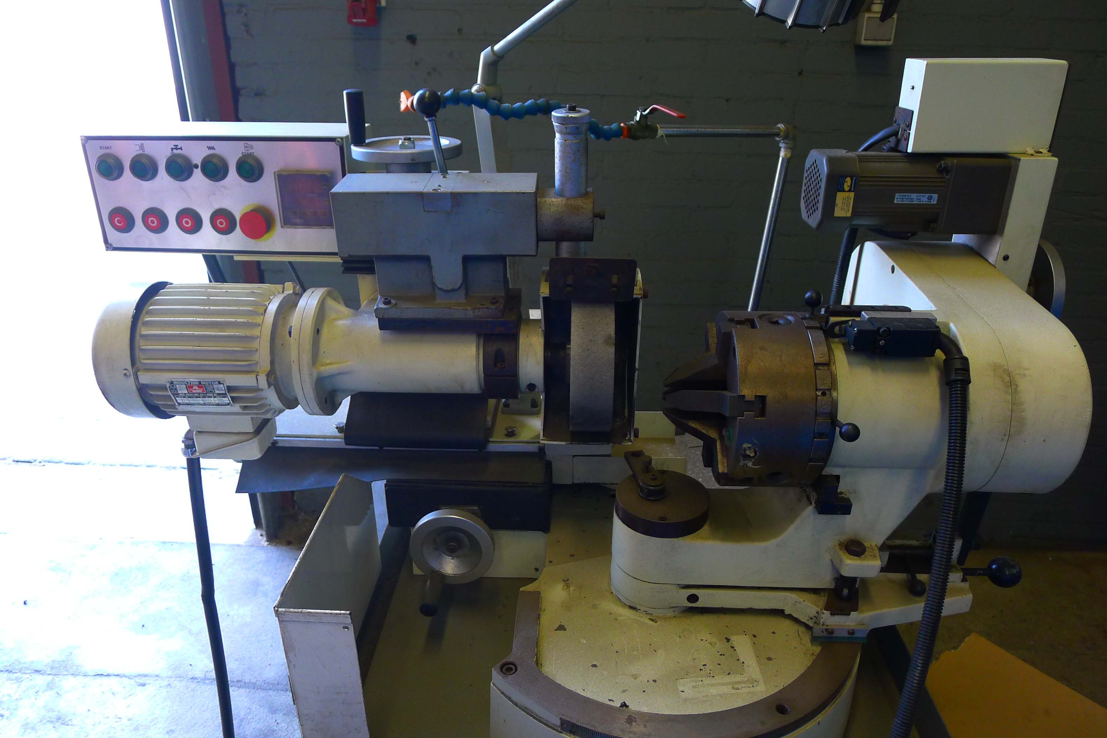
- Make : Farman Taiwan
- Typ : FC 80 N
- Mach.No : 080116
- Age : 2008

- Tool mounting in chuck Min. Ø : 4
- Tool mounting in chuck Max. Ø : 80

- Minimum point angles : 40˚
- Maximum point angles : 180˚
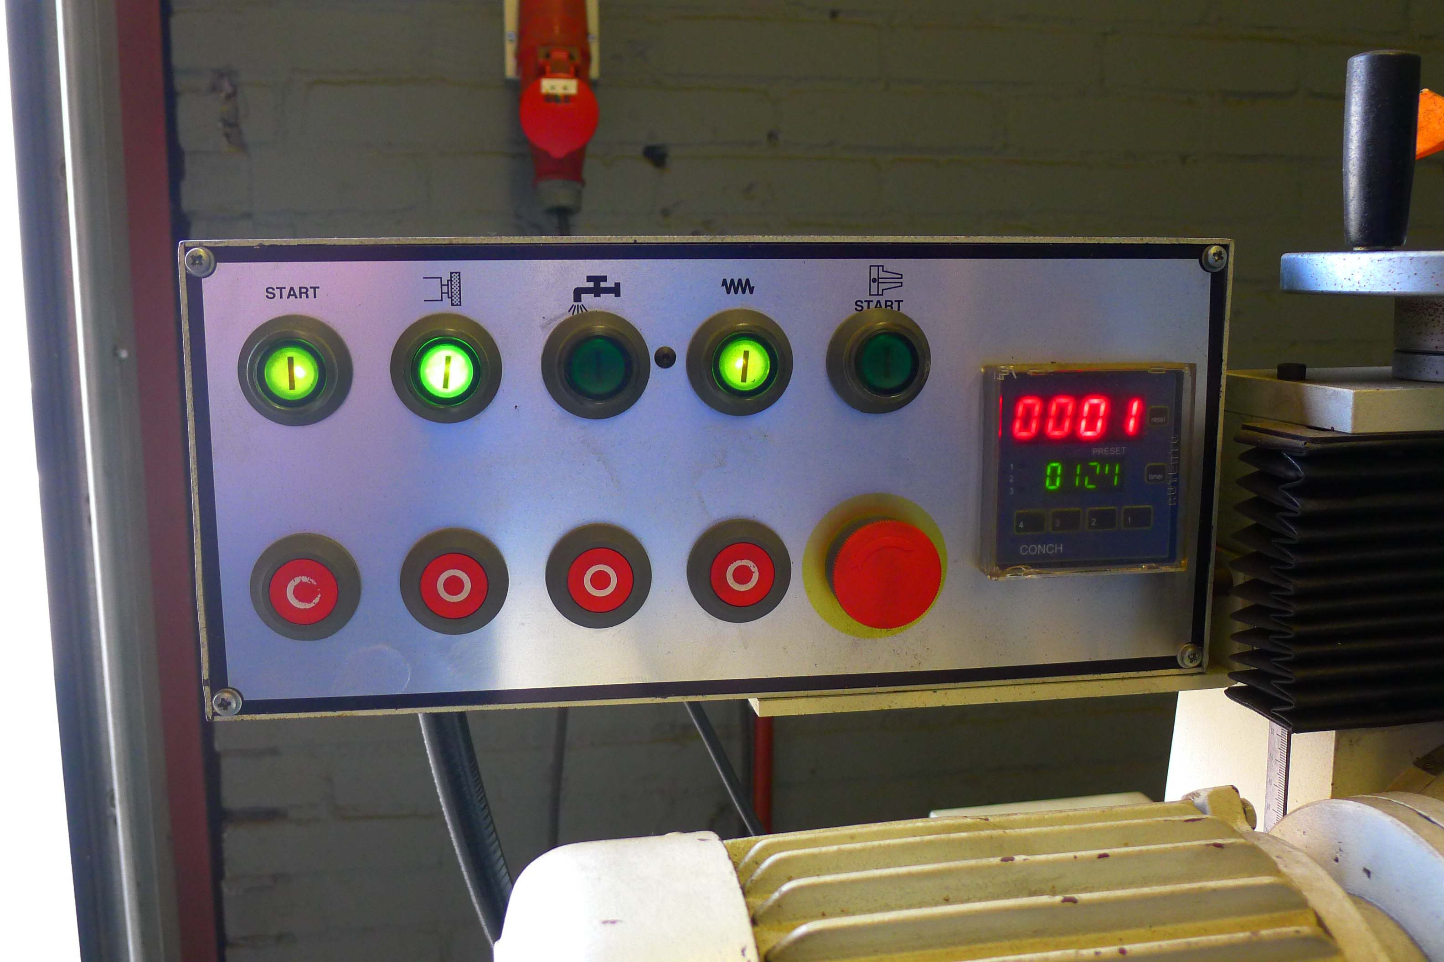
- Clearance angle : 0 - 18˚
- Grinding wheel : 180 x 50 x 31,75
- Motor power : 3 HP / 400 V

- Grinding the end of end mills :
- 2 / 3 / 4 / 6 12 flute
- Number off jaws in chuck 6 x

- Dimensions
- Length : 800
- Width : 1.000
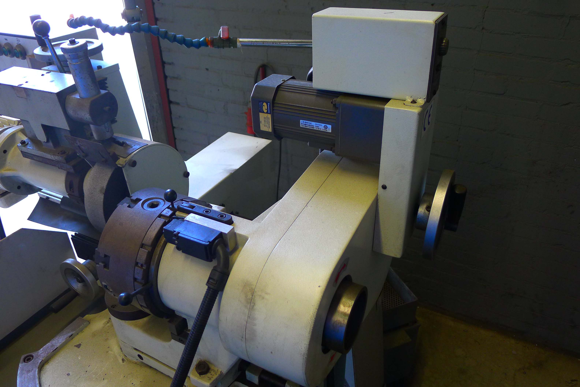
- Height : 1.300
- Weight : 380 Kg

- Incl. coolant system
- Incl. dressing system
- Very little used
- New price Euro

Please Note: The above information has been obtained to the best of our ability and belief from, and from the manufacturers where possible. It is given in good faith, but its accuracy can not be guaranteed. Accordingly, it will not form a representation or constitute contractual terms. We advise you to check any vital details!

